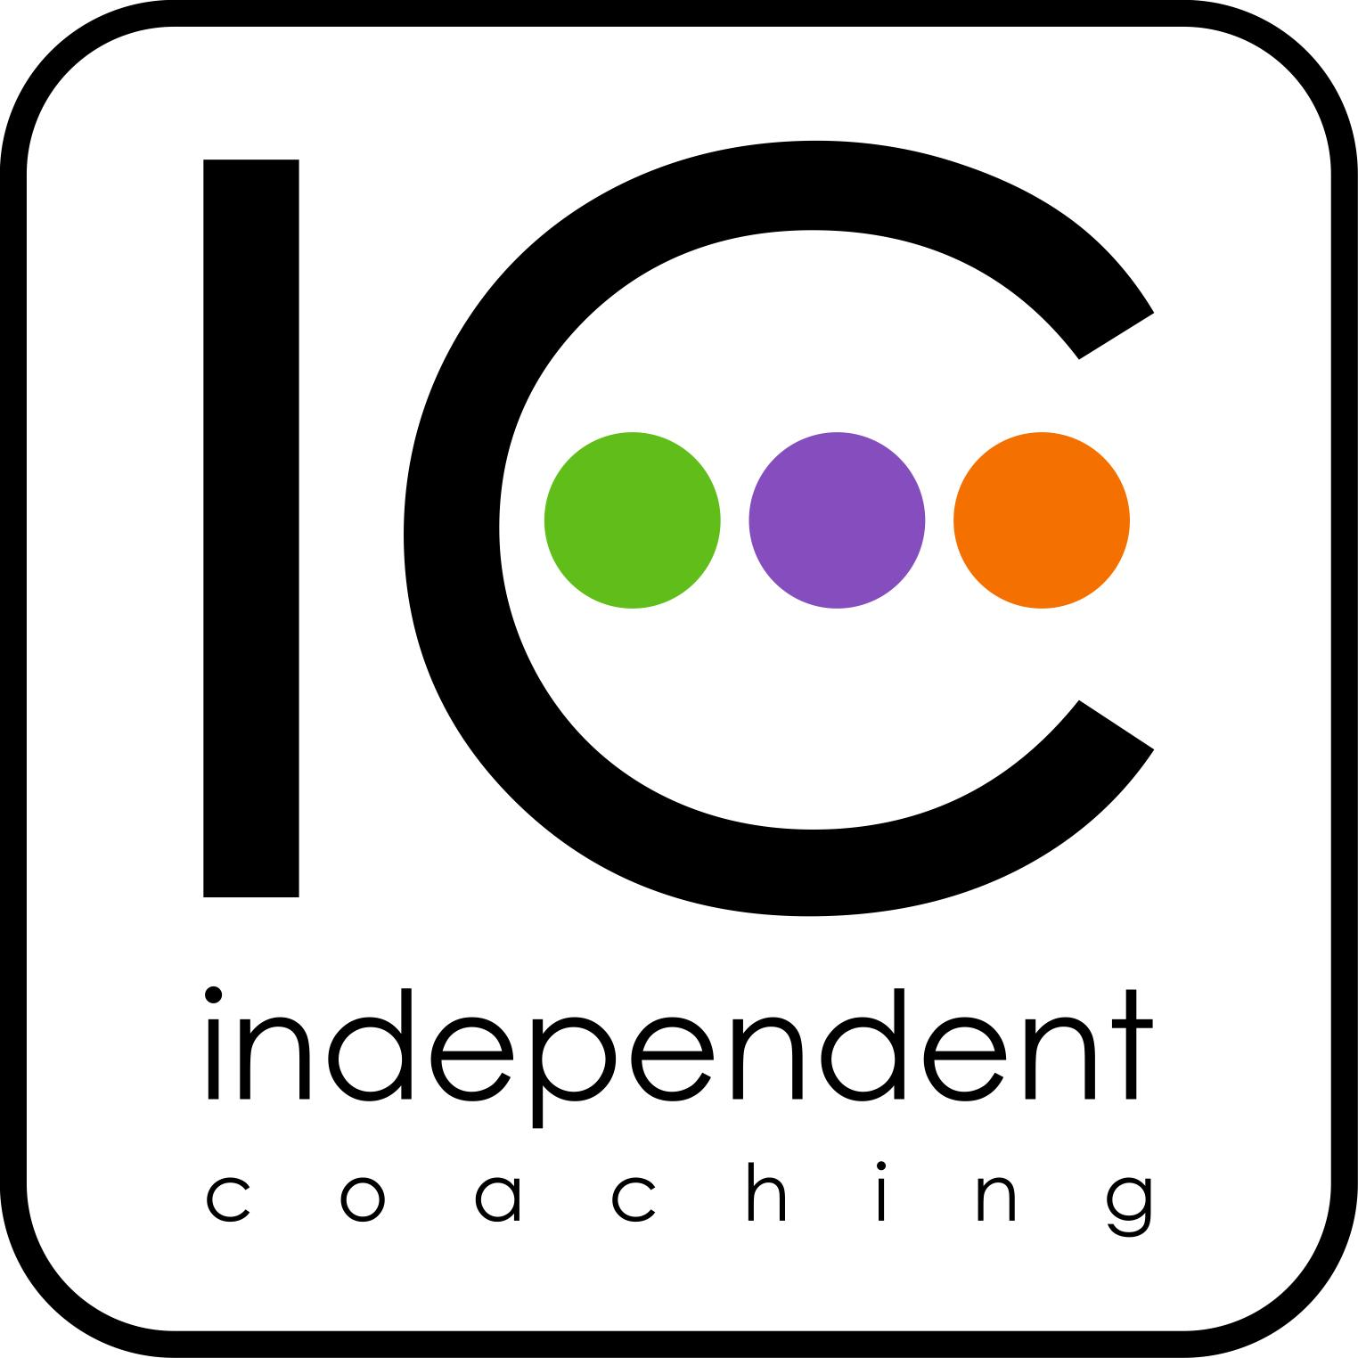
The Leadership Coaching Skills Programme
~ curriculum themes and progression

Part 1 Personal leadership: awareness and responsibility | Part 2 Organisational leadership: performance and accountability | Part 3 Strategic leadership: coaching and culture
The nature of influence  The landscape of coaching  Listening, real listening  Three Circles: Reality-Ideal-Action  EI: emotional intelligence  Creativity: sources of Ideal  The Action-Learning cycle  Q1/Q2: time and values  Personal leadership | The Service triangle: self, service and others  Systems thinking: dynamics and energy  Action – Values (Five Levels)  Iceberg: social role and self image  Leadership as a sense of self  Contracting, ethics and boundaries  Teams, emotion and performance  EVE: emotion, values and ethics  Coaching in the organisation | The organisation as whole  The nature of culture  Social capital  Courage and compassion  Central coherence  Cognitive ease  Integration and integrity  Presence and voice  Intuition and risk
Reflective practice > Coaching Partners >

